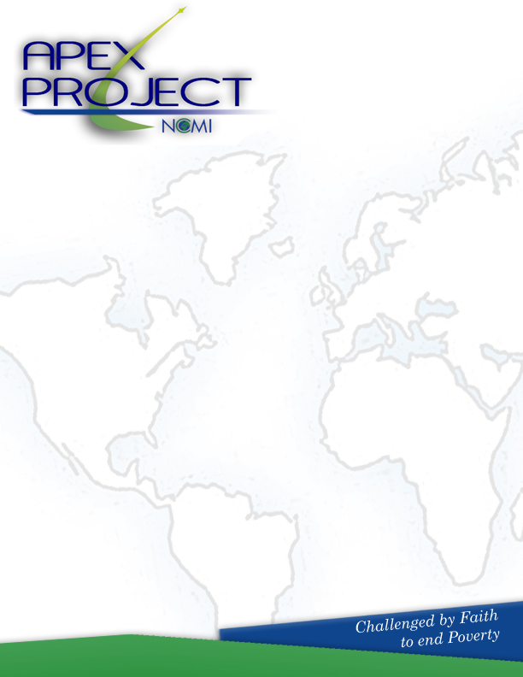

POLICIES AND PROCEDURES

FOR SECURING AN APEX CONSULTANT
Access
The Apex Project is a assessment and consulting service available through Nazarene Compassionate Ministries, Inc. to all churches and compassionate ministry centers working with the poor. Services offered include:
  - Organizational consultation for assessment and development. These are individual appointments made with registered APEX consultants in accordance with the specifications outlined in this document. See fee schedule on page 6-7.
  - Seminars and group training. See fee schedule on page 6-7.

Dates for services

- Consultation will be available by appointment with registered consultants.
- Seminars may be conducted at the specified locations, but centrally located training will be announced periodically at www.nazarenecompassion.org, www.ncmi.org, and www.apexncm.org.

Processing of Requests
- Consulting requests are processed by NCMI staff. Procedures are detailed on page 4-5.
- A consulting request is made by either of the following methods:
    - By e-mail: apex@ncmi.org
    - By telephone: 913.768.4808 or 913.660.3734
    - Through web-based materials: http://www.apexncm.org/consultantscoaches.html

It is strongly recommended to fill out the Consulting Request Form (http://www.apexncm.org/consultantscoaches.html) on the web site prior to making personal contact.

Liability, Responsibility
Nazarene Compassionate Ministries, Inc., and Nazarene Compassionate Ministries USA/Canada do not assume responsibility for the correctness of advice given.

These policies may be subject to change.

WHAT IS CONSULTING?

In a sentence, a consultant is one who attempts to influence or change a person, group, or organization but has no direct power to implement the recommended changes.

The one sentence definition above is helpful but is not exact enough to adequately define the work of a consultant. Let’s consider a more thorough definition of a certain kind of consulting: management consulting.

Management consulting is an independent and objective advisory service provided by qualified persons to clients in order to help them identify and analyze management problems or opportunities. Management consultants also recommend solutions or suggested actions with respect to these issues and help, when requested in their implementation. In essence, management consultants help to effect constructive change in private or public sector organizations through the sound application of substantive and process skills.

Now, let’s look at this definition phrase by phrase:

“an independent and objective advisory service.”
Have you ever said, “I wish that I had an objective opinion on this situation?” One of the greatest services APEX can offer is to provide objective advice, when requested, to a ministry center and/or church.

“identify and analyze management problems or opportunities.”
The consultant comes in to be a friend and advisor. But, everyone needs a professional to look at the present situation from the view of an outside observer.

“recommend solutions … and help, when requested in their implementation.”
Receiving recommendation is important. The APEX consultant comes with a willingness to assist where necessary to implement the solution. We will help you work with local boards, communities, district boards, and the leadership involved in this.

“through the sound application of substantive and process skills.”
It takes skill to be a good consultant. Secular companies will pay their consultants US$150 per hour or more because of the skills the consultants bring to a situation. APEX believes the work in the kingdom is immeasurably more important and can result in eternal dividends!

Do You Need A Consultant?

The APEX Project has a team of nationally qualified coaches and they all have been successful pastors, non-profit executives, and/or community and denominational leaders. They understand the APEX training system very well and are there to help you implement your plan with skill, accountability and encouragement.

The NCM, Inc. Consulting Office is located in Lenexa, KS. You may contact us in the following ways:

NCM, INC. – Consulting
The APEX Project
12351 W, 96th Terrace, Suite 100
Phone: Toll Free: (800) 214.4999
Local: 913.768.4808
Fax: 913.768.7752
E-Mail: apex@ncmi.org

There are usually four parties involved in APEX Consulting Contracts:
1) The individual, church, or ministry
2) The APEX consultant
3) The district superintendent or denominational supervisor
4) The NCM, Inc. and/or NCM USA/Canada Offices.

APEX never "assigns" a consultant because we believe that good consulting is best delivered when "affinity" is present. For that reason, when you are seeking to secure a consultant, the APEX office suggests two or three individuals for you to interview. The group or individual being consulted makes the final decision regarding consultant selection.

STEPS TO SECURING A CONSULTANT

Here are the basic steps to follow in securing an APEX qualified consultant:
.
- Fill out a Consultant Request Form (on line or on page ____ of this document) which assesses your particular situation.
- Contact the APEX Office, expressing your interest in securing a consultant.
- Interview and select a consultant from among the individuals sent to you for consideration.
- Inform the APEX Office of your decision and ask them to draw up a first-draft contract.
- APEX will e-mail the initial contract to all parties involved for approval.
- After both feedback and approval from all parties involved, the contract is put into effect.

NCM, Inc. Mission Statement:
NCM, Inc. provides global crisis response and long-range empowerment of the poor using resources that create self-reliance, dignity and respect.

What is NCM, Inc (NCMI)?
“Linking Resources with Needs” Nazarene Compassionate Ministries, Inc. (NCM, Inc.) was created so people can respond to the immediate physical needs of economically disadvantaged individuals and communities around the world.
NCM, Inc. is committed to long-term solutions as well as immediate crisis response.
NCM, Inc. extends its ability to link resources with needs through affiliations with partner organizations, both domestically and globally.
NCM USA/Canada uses the resources of NCMI to facilitate the capacity development and training of Compassionate Ministry Centers.

APEX Consulting Vision

The vision of Nazarene Compassionate Ministries, Inc. is that every Church and/or Compassionate Ministry Center working among the poor will have professional assistance in developing their skills to meet the purposes for which they were created. This will include each leader we work with going through a clearly defined training process. We also envision every leader becoming competent in their understanding of the best available resources and submitting to the discipline of writing a detailed Ministry Action Plan. The Action Plan should cover the process of taking a leader and their ministry through complete planning for at least one year and preferably for 3-5 years.

Our vision is also that every leader and organization will have available to them, a qualified consultant who will assist the organization in the following process:
1) Self-evaluation. Each leader will be guided through a fair assessment of their present level of organizational development using the assessment tool developed by NCMI.
2) Self-analysis. The consultant will advise and assist the creation of a plan for advancing the organization and its leaders to the level they desire to obtain.
3) Goal Setting. This plan will be set into a time table and a monthly goal list will be developed.
4) Re-assessment. In the time table will be a mutually agreed upon time for re-assessment and adjustments to the original time table.
5) Final Evaluation. At the end of the contract period an evaluation will be made of the leaders, the organization, and the consultant.

APEX PROJECT SERVICES & COSTS:

At NCM, Inc. through APEX we are committed to extend multiple services and resources to assist the local church and ministry to achieve their vision and objectives for healthy development.

The following information is to inform the applicant of the current rate of the services APEX provides. Districts and local ministries may petition NCM, Inc. or NCM USA/Canada for financial assistance if needed.

Assessment

1. Organizational Development System Asssement (on line at no charge)

This survey helps measure the present level of development in seven key characteristics including Legal Documentation, Mission/Vision Planning, Board Development, Financial Accountability, Fund Development, Human Resources, and Program Development. The goal is to establish the ministry’s present level from 1-4 in each of 36 categories within these 7 characteristics.

2. APEX Consultation and one year plan ($1200.00 plus travel expenses)

This two day on site assessment includes all the assessment tools mentioned above as well as interviews with key leaders; Facility evaluation; program evaluation and an attitude observation. It also includes a meeting with the board of directors and staff. The multi page detailed report is delivered to ministry leadership with specific conclusions and recommendations. A one year plan of development is produced.

Mission, Vision and Core Value Development

3. Mission, Vision and Core Value Development ($1200 plus travel expenses)

This two day retreat type setting with the leadership team is led by an APEX consultant. The desired outcome is a completed Mission statement and core value statements and a first draft vision description.

4. Sample Mission, Vision and Core Value Statements (Available on line at www.apexncm.org )

For the past several years we have been collecting Mission, Vision and Core Value statements. Those statements are delivered electronically to your desktop in Word format to use as discussion starters and examples.

Harmony & Strategic Planning

5. Spiritual Renewal Weekend ($1500 plus travel expenses)

The focus of this renewal weekend is helping those attending to understand the Biblical teaching of renewal through ministry to the poor and neglected. This Friday evening, Saturday extended seminar, prayer, and Bible teaching time, and Sunday morning service, is designed to instruct a local church and/or community in the responsibility and renewal possibilities through serving those in need.

6.Strategic Planning ($1500 plus travel expenses)

This two day retreat setting workshop leads the leadership team of the church and/or CMC in the process of developing a strategic plan which includes specific goals and action steps.

Training

7. Local Church/CMC Training($1500 plus travel expenses)

This intense two day training is for local church leaders and is delivered on site by a NCMI or NCM USA/Canada Senior Staff member.

FREQUENTLY ASKED QUESTIONS
Who are the Consultants?
Consultants are professionals who presently are serving as pastors, executive directors, denominational executives, or other individuals. They are certified and trained by Nazarene Compassionate Ministries, Inc., and have given their lives to serving the poor.

Is there a Fee?
The fee structure and services offered are outlined on pages 6-7. Districts and local ministries may petition NCM, Inc. or NCM USA/Canada for financial assistance through funds raised from outside sources. None of these funds are taken from Great Commission funds donated by local churches around the world.

When Should I Contact the NCMI. Office?
Contact should be made with the Nazarene Compassionate Ministries, Inc. office after the Consultant Request Form is completed and the District Superintendent has approved this consultation.

Who Can Use APEX Services?
This service is limited to churches and compassionate ministry centers that primarily are working with the poor.

What if there are follow-up questions?
Follow-up questions are very common. Contact NCM, Inc., directly on their web site: www.apexncm.org or email communications to apex@ncmi.org.

CONSULTANT REQUEST FORM
(Updated 6/08)

Scholarships for consultations using professionals fitting the need of the requesting organizations may be available upon request through funds raised by Nazarene Compassionate Ministry, Inc. and Nazarene Compassionate Ministries USA/Canada. None of these funds are taken from Great Commission funds donated by local churches around the world.

Requirements and Restrictions

- Consultant requests are granted only to registered Nazarene Compassionate Ministry centers and/or churches working with a population living at or below 125% of the government agreed poverty level.
- Requests are made only to cover the travel, expenses, and honorarium of the consultant during the contract period. These funds cannot be used for salaries or program expenses of the local organization.
- The consultation will involve a visit to the proposed site, and follow up as detailed in the contract.
- A written contract will be signed by the consultant, the Executive Director and/or Pastor, and the District Superintendent.
- A consultant’s services usually covers a one year span, but can be extended at the request of the organization in question and the district on which they serve. Extensions shall not be at the expense of NMC, Inc.

Instructions and Guidelines

- Include in the request a short summary of the ethnic and socio-economic make up of your immediate community. Include documentation with recent sources that show the level of need in relation to State and National statistics.
- Provide a list of Board Members including their professional occupation as well as their volunteer place of service in the ministry and/or church.
- Attach the ministry budget for this year and year end financial report for the last two years (if applicable).
- Outline the mission, vision, and objectives of the ministry. Give several sentences detailing how these statements were established (i.e., written by the pastor/executive director, established in a retreat setting and adopted by the Board, etc.)
- These items should be attached to the form below and print, sign and submit to the NCM INC. Office at:

    - NCM, INC.
APEX Project
12351 W. 96th Terrace, Suite 100
Lenexa, KS 66215

Consultant Request Form (Page 2)

This form must be completed by the Church or Compassionate Ministry Center when planning to engage a consultant, using funds requested through NCM, Inc. Make sure it is signed and dated all of the individuals indicated.

Ministry or Church
Mailing Address
City, State, Zip Code
Phone Contact
Fax Number
Person to contact
Title or position
Email Contact
Website (if applicable)

Describe the community with which you work. This can be an ethnic group or a specific community. Limit this to 500 words or less. Please, document your information with recent and recognized sources.

Consultant Request Form (Page 3)

List at least two reasons you think a consultant will be helpful, will stabilize and will increase the organizations sustainability.
1.
2.

Place of desired services (city, state, and specific meeting place)

Description of services (Attach additional sheet, if necessary.) Give any other services you wish to see accomplished during a site visit and continued coaching.

Responsible officials:
We, the undersigned support this application and will do everything possible to make this consultation a success:

(Signature, Executive Director) (Date)

(Signature, Pastor) (Date)

(Signature, District Superintendent) (Date)

APPROVAL BY NCM, INC.
ASSIGNED TO CONSULTANT
(NAME AND LOCATION)

